Order Management System

Project Title : Order management Database System
Student Name : Yakesh J
Register Number : C4S38024
Department : B.Sc Artificial Intelligence
Course : Artificial intelligence (AI)
Academic Year : 2024 – 2027

1. Design Orders and Order_Details tables
CREATE DATABASE OrderManagement;
USE OrderManagement;

CREATE TABLE Orders (
order_id INT PRIMARY KEY AUTO_INCREMENT,
customer_id INT NOT NULL,
order_date DATE NOT NULL,
total_amount DECIMAL(10,2) DEFAULT 0.00
);
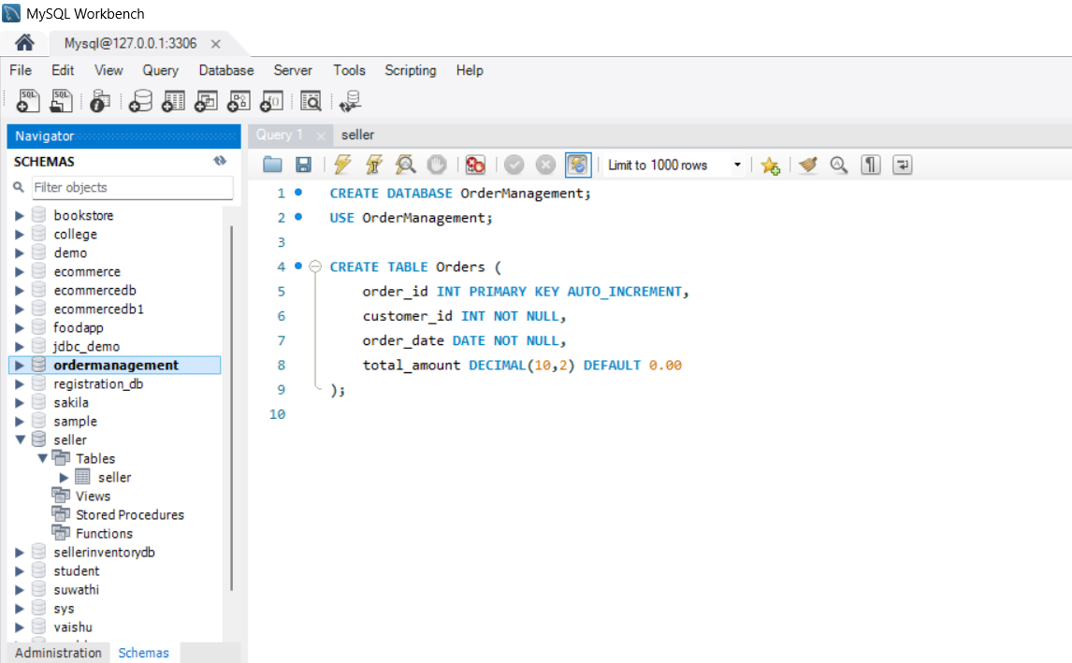

CREATE TABLE Order_Details (
order_detail_id INT PRIMARY KEY AUTO_INCREMENT,
order_id INT NOT NULL,
product_id INT NOT NULL,
quantity INT NOT NULL,
unit_price DECIMAL(10,2) NOT NULL,
subtotal DECIMAL(10,2) GENERATED ALWAYS AS (quantity * unit_price) STORED,

FOREIGN KEY (order_id) REFERENCES Orders(order_id)
);
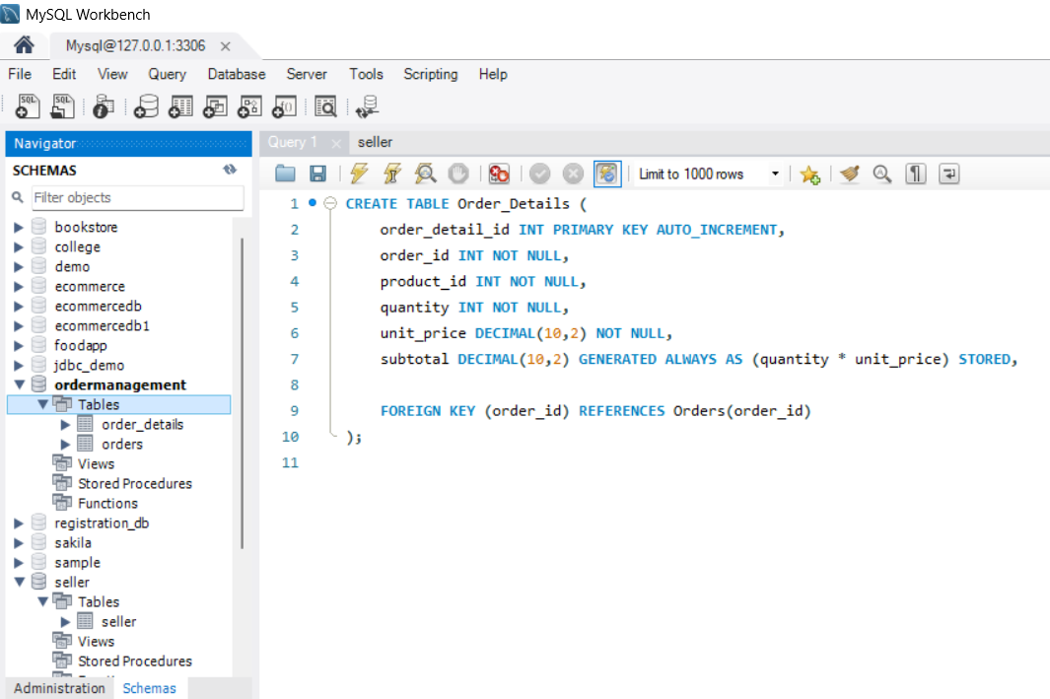
2. Manage customer product orders
Insert a new customer order:
INSERT INTO Orders (customer_id, order_date, total_amount)
VALUES (101, CURDATE(), 0.00);
Insert products into the order:
INSERT INTO Order_Details
(order_id, product_id, quantity, unit_price)
VALUES
(1, 201, 2, 500.00),
(1, 202, 1, 750.00);
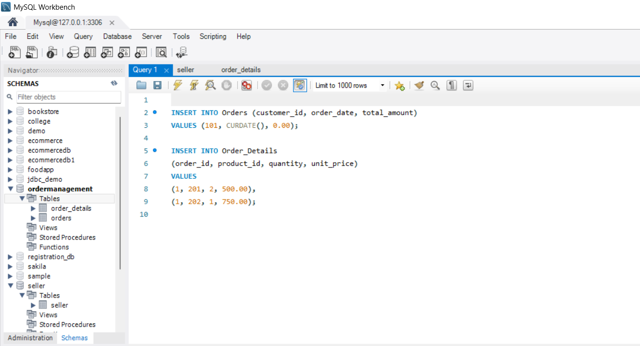
3. Store Order Date, Quantity, and Total Amount
Calculate and update the total amount:
UPDATE Orders
SET total_amount = (
SELECT SUM(subtotal)
FROM Order_Details
WHERE order_id = 1
)
WHERE order_id = 1;
Check the order:
SELECT *
FROM Orders
WHERE order_id = 1;
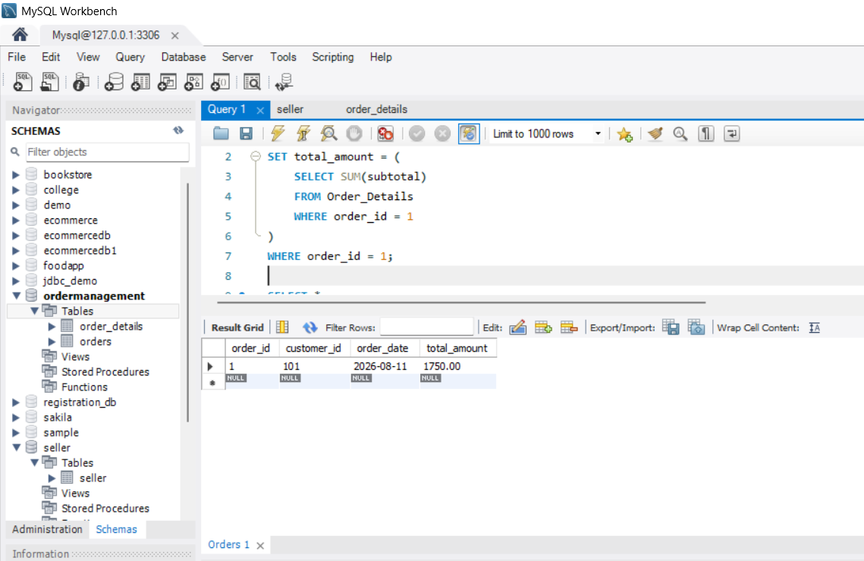
4. Perform order insertion and modification operations
Modify order quantity:
UPDATE Order_Details
SET quantity = 3
WHERE order_detail_id = 1;
Modify product price:
UPDATE Order_Details
SET unit_price = 550.00
WHERE order_detail_id = 1;
Update total amount after modification:
UPDATE Orders
SET total_amount = (
SELECT SUM(subtotal)
FROM Order_Details
WHERE order_id = Orders.order_id
)
WHERE order_id = 1;
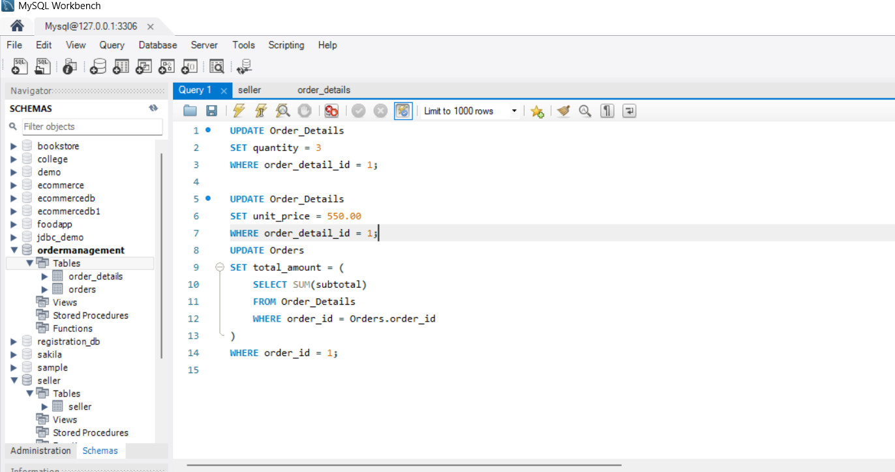
5. Generate customer order history reports
SELECT
o.order_id,
o.customer_id,
o.order_date,
od.product_id,
od.quantity,
od.unit_price,
od.subtotal,
o.total_amount
FROM Orders o
JOIN Order_Details od
ON o.order_id = od.order_id
WHERE o.customer_id = 101
ORDER BY o.order_date DESC;
